Topic: Project Design and Outline

Tripti Vishwakarma
Colorado State University Global
Course Code: CSC 501-2
Bingdong Li
Aug 17, 2024

Outline of Processes Required for Design Methodology

Project Name: Design and Implementation of a Software Life Expectancy Model
Project Manager: Tripti Vishwakarma
Start Date: September 15, 2024
End Date: January 19, 2025
Budget: $150,000

1. Project Scope

Objectives:
- Develop a predictive model to estimate software life expectancy.
- Integrate the model with the existing software systems.
- Validate the model’s accuracy with real-world data.
- Provide comprehensive documentation and training for stakeholders.

Deliverables:
- Predictive Model: Functional model for estimating software life expectancy.
- Integration: Model integrated with existing software systems.
- Validation Report: Documentation of testing and validation results.
- Documentation: Manuals, technical documentation, training materials.
- Training: Training sessions and workshops for stakeholders.

Out of Scope:
- Major software updates beyond integration.
- Long-term support beyond initial training and documentation.

2. Project Timeline

Phase 1: Project Initiation

- Start Date: September 15, 2024
- End Date: September 21, 2024
- Duration: 1 week
- Activities: Kickoff meeting, stakeholder alignment, initial planning.

Phase 2: Requirements Gathering

- Start Date: September 22, 2024
- End Date: October 5, 2024
- Duration: 2 weeks
- Activities: Collect and document requirements, stakeholder interviews.

Phase 3: Design
- Start Date: October 6, 2024
- End Date: October 19, 2024
- Duration: 2 weeks
- Activities: Design model architecture, create design specifications.

Phase 4: Development
- Start Date: October 20, 2024
- End Date: December 1, 2024
- Duration: 6 weeks
- Activities: Develop predictive model, initial integration with systems.

Phase 5: Integration
- Start Date: December 2, 2024
- End Date: December 15, 2024
- Duration: 2 weeks
- Activities: Complete model integration, resolve issues.

Phase 6: Testing & Validation
- Start Date: December 16, 2024
- End Date: December 29, 2024
- Duration: 2 weeks
- Activities: Conduct tests, validate accuracy, prepare report.

Phase 7: Documentation & Training
- Start Date: December 30, 2024
- End Date: January 12, 2025
- Duration: 2 weeks
- Activities: Prepare documentation, conduct training sessions.

Phase 8: Project Closure
- Start Date: January 13, 2025
- End Date: January 19, 2025
- Duration: 1 week
- Activities: Finalize deliverables, obtain approval, conduct review.

3. Design Methodology Processes

3.1 Requirements Gathering
- Objective: Collect and document all necessary requirements from stakeholders.
- Activities:
  - Conduct stakeholder interviews.
  - Review existing documentation and systems.
  - Create a requirements specification document.
- Tools: Jira, Confluence, MS Word.

3.2 Design
- Objective: Develop a detailed design for the predictive model and its integration.
- Activities:
  - Design model architecture.
  - Create design specifications and diagrams.
  - Review design with stakeholders for feedback.
- Tools: Visual Studio, Eclipse, MS Visio.

3.3 Development
- Objective: Develop the predictive model and integrate it with existing systems.
- Activities:
  - Code the predictive model using Python or R.
  - Integrate the model with the existing software.
  - Conduct unit testing to ensure functionality.
- Tools: Python, R, Git, Visual Studio.

3.4 Integration
- Objective: Ensure the predictive model is fully integrated and functional within the existing software ecosystem.
- Activities:
  - Complete integration tasks.
  - Resolve any integration issues.
  - Conduct integration testing.
- Tools: Git, Jenkins, Selenium.

3.5 Testing & Validation
- Objective: Validate the accuracy and reliability of the predictive model.
- Activities:
  - Develop test cases and scenarios.
  - Conduct testing using real-world data.
  - Document and analyze test results.
- Tools: Selenium, JUnit, MS Excel.

3.6 Documentation & Training
- Objective: Provide comprehensive documentation and training for stakeholders.
- Activities:
  - Prepare user manuals and technical documentation.
  - Conduct training sessions and workshops.
  - Gather feedback and make necessary adjustments.
- Tools: Confluence, MS Word, PowerPoint.

3.7 Project Closure
- Objective: Finalize the project and ensure all deliverables meet stakeholder expectations.
- Activities:
  - Finalize and deliver all project documentation.
  - Conduct a post-project review to capture lessons learned.
  - Release project resources and formally close the project.
- Tools: Jira, Confluence, MS Word.

Gantt Chart-

Below is a manually created Gantt chart for the project timeline. This chart provides a visual representation of the project phases and milestones.

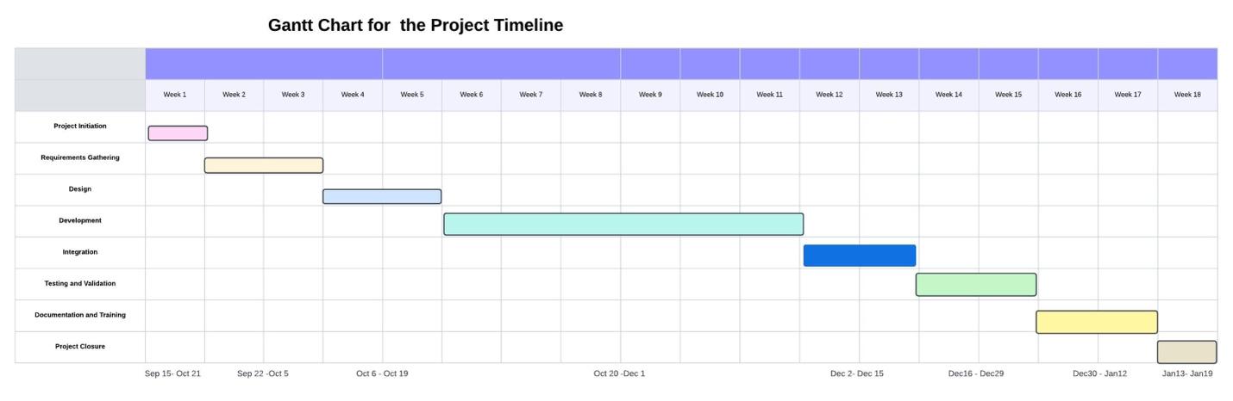

The design and implementation of a software life expectancy model is a complex project that requires careful planning and execution. By following a structured design methodology, the project team can ensure that the model meets all requirements, integrates seamlessly with existing systems, and provides value to stakeholders. The attached Gantt chart provides a visual representation of the project timeline, highlighting key phases and milestones.

References-

- Meredith, J. R., Shafer, S. M., & Mantel, S. J. (2017). Project Management: A Managerial Approach (10th ed.). Wiley.
- Pinto, J. K. (2019). Project Management: Achieving Competitive Advantage (5th ed.). Pearson.
- PMI. (2021). A Guide to the Project Management Body of Knowledge (PMBOK Guide). Project Management Institute.

